From: http://davidstockmanscontracorner.com/peak-trump-why-the-undrainable-swamp-wins-again-part-1/

Peak Trump! Why The Undrainable Swamp Wins Again, Part 1
By David Stockman. Posted On Monday, September 17th, 2018
The history books will record, ironically, that the Donald peaked in September 2018.
Obviously, that was the 10th anniversary of the Lehman financial meltdown. But the original event and its current commemoration actually book-end why Trump came out of nowhere, sojourned briefly in the Oval Office, and then fell victim to an even greater crisis that will end in ignominy for the Donald and in staggering political and economic setbacks for the nation.
The original Lehman event was actually a symptom of the national economic breakdown which brought Trump to power against all odds. That is, decades of fiscal profligacy and egregious money-pumping by the Fed have
- deeply impaired and
- capriciously bifurcated
the national economy and polity.
On the one hand, soaring household debts, relentless inflation of domestic costs, prices and wages and an addiction to destructive financial engineering in the corporate C-suites have de-industrialized much of the vast expanse of Flyover America. These wrong-headed Washington policies have caused the off-shoring of massive amounts of America's productive base and generated enormous and chronic current account deficits, which have turned the US into the greatest debtor nation in history, owing the rest of the world more than $9 trillion.
At the same time, Washington's foray into statist destruction of sound money and fiscal rectitude has capriciously conferred financialized prosperity on selective pockets of American society scatted along the coasts and in the hinterlands. These economic precincts have prospered mightily---albeit unsustainably---from both the vast bloating of the financial sector and the relentless inflation of financial assets, as well as from the tax-and-debt fueled state enterprises of war, medical care and education.
In this context, the crisis of September 2008 represented the first down-leg of financialization coming undone. At that point, the so-called financial crisis was essentially concentrated in the canyons of Wall Street owing to the blow-up of the securitization meth labs, which, in turn, set off a contagion of falling prices for these and other dodgy assets held in investment bank inventories.
The latter had been accumulated during the subprime mortgage, real estate and credit booms that the Fed had ignited after the dotcom crash. When soaring defaults on the underlying mortgages caused a sell-off of the securitized derivatives, the liquidation accelerated rapidly owing to the Fed's folly of mechanically pegging and transparently telegraphing its money market interest rate targets.
That is to say, this kind of absolute money market certainty had encouraged Wall Street to recklessly fund these risky, sticky, longer-term mortgage, real estate and junk bond assets with hideously mismatched liabilities. These consisted heavily of hot, short-term money market instruments (unsecured commercial paper and repo) that suddenly dried up in the summer of 2008, forcing dealers to dump even more toxic junk into the market.
Still, the fallout of the Wall Street crisis had initially penetrated Flyover America only by virtue of the mortgage refi machine and the predation of the mortgage broker boiler rooms that peddled low-rate ARMS (adjustable rate mortgages) to economically marginal households. The latter, of course, could not remotely hope to afford these subprime mortgages after the ultra-low "teaser" rates reset and escalated sharply higher.
In fact, by the eve of the crisis, refi-based mortgage equity withdrawal (MEW) had reached a $900 billion annual rate, thereby goosing household consumption spending by up to 9% of disposable personal income (DPI), while the subprime boom was generating record levels of home prices, new construction and existing unit turnover.
Both came to a screeching halt when Wall Street melted-down, triggering what would have otherwise been a mild-downturn in the housing sector. But what transformed the so-called Great Recession into a rout on main street was the C-suite response to plunging stock prices in the fall and winter of 2008-2009.
To wit, by then the Fed's cancerous regime of Bubble Finance had turned the C-suites of corporate America into options obsessed stock trading rooms and financial engineering joints. Almost instantly, a recession that was not even visible in the summer of 2008 to the Goldilocks worshipping economists of both Wall and Washington alike turned virulently south as depicted below.
But the crash of business inventories and employment shown in the chart happened not for the classic reason that interest rates were soaring and household and business credit got crunched, but because the C-suites were desperately attempting to propitiate the new trading gods of Wall Street.
The sacrifices they offered consisted of sweeping so-called "restructuring" plans that amounted to shit-canning payrolls, inventories, facilities and balance sheet assets with nearly reckless and frenzied abandon.
During the brief 11-month period after August 2008, more than 6 million workers were tossed overboard and $150 billion of inventories or 10% of outstandings were hastily liquidated.
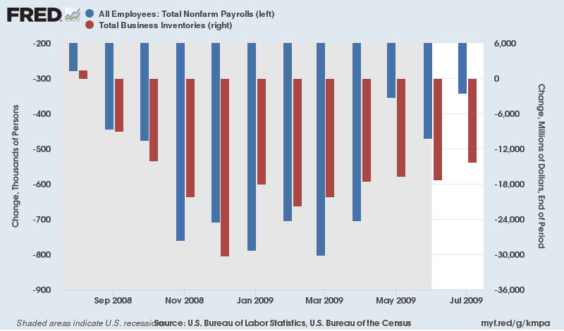
Even a superficial post-mortem of the data shows that the Great Recession was a drastic over-reaction based on the underlying economics; demand did not fall by anything close what was implied by the C-suite initiated sturm und drang.
But it was a godsend to the Keynesian money-pumpers at the Fed who had actually caused the subprime crash and Wall Street meltdown in the first place. Instead of finding themselves impaled on the hot-seat of blame that they deserved, they swiftly turned the tables, morphing into putatively heroic economic firemen who saved the day.
Most especially, the C-suites' frenzied assault on their own employees and company operations permitted the phony Great Depression scholar and inflationista who had become Fed head, Professor Ben Bernanke, to run around Washington with his hair on fire. So doing, he hysterically claimed that a reprise of the 1930s was at hand; and that extraordinary and heretofore unimaginable levels of monetary and fiscal intervention were needed to arrest a slide into armeggedon.
Needless to say, the entire Bernanke-inspired narrative was unadulterated hogwash. The circumstances of 2008 were not remotely similar to those of 1930, most notably because back then America was a massive global creditor and exporter, which got monkey-hammered when the stock market and foreign subprime loan bubble of the day crashed in October 1929.
That caused foreign demand for what had been booming exports and domestic demand for what had been urgently needed expansion of plant and equipment during the Roaring Twenties to crater, thereby necessitating a genuine old-fashioned liquidation of excess inventories, fixed capital, labor and unsustainable bank credits.
In contrast, by 2008 America was already
- a giant global debtor and importer. Washington was also
- a prodigious dispenser of Welfare State income and safety nets,
- the principal financier of what had become massive domestic health care and education cartels and
- a fount of money for the nation's obscenely bloated war machine.
Accordingly, there was not a snowball's chance in the hot place that demand and domestic economic activity would have meaningfully declined; and most certainly no chance at all that any modest adjustment would have become a self-fueling depressionary spiral.
In fact, the structure of the American economy in 2008 was upside-down from that of 1930: The Hoovervilles actually sprung-up amidst the time-immemorial poverty of the Chinese countryside. That happened in the fall and winter of 2008-2009 when global trade swooned and upwards of 100 million suddenly redundant migrant workers were sent from the closed-down export factories in eastern China back to the interior rice paddies.
But the pettifogging professor at the helm of the US central bank did not wait even a few weeks for the smoke in the canyons of Wall Street to clear after Lehman went down; and for it to become obvious that the real recession was destined to happen in China, not the already burned-out precincts of Rust Belt America.
So the Fed doubled-down into a frenzy of liquidity pumping that amounts to the financial policy crime of the century. On September 3, 2008 the balance sheet of the Fed was $905 billion and it had taken 94 years to get there from the day the Fed opened for business in 1914.
Yet by November 12 after an insane frenzy of liquidity pumping the Fed's balance sheet stood at $2.213 trillion.
So in just 71 days a no count academic scribbler---- who ended up on the Fed by accident because the political hatchet men around George W. Bush didn't trust Easy Al Greenspan to be easy enough (imagine that!) if electioneering so required----increased the Fed's balance sheet of plucked-from-thin-air liabilities by 145% more than all his predecessors had done during the first 94 years of the Fed's existence.
And then, after the fact, this mountebank had the nerve to brag about having had the "courage" to print!
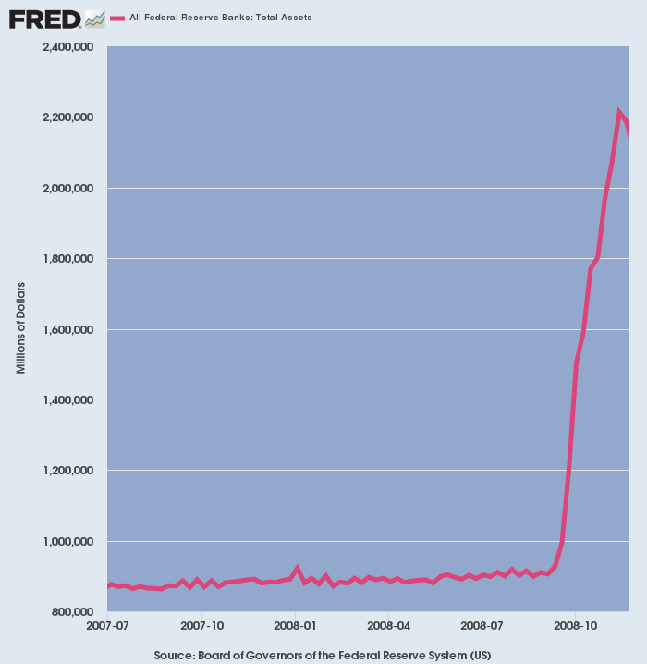
Bernanke's monetary crime was all the more breathtaking because it was utterly uncalled for. He and the former Dartmouth line-backer and apparent CTE victim (chronic traumatic encephalopathy), Hank Paulson, who had been sent to Washington by Goldman Sachs to occupy the Secretary of Treasury's office, had single-handedly panicked Capitol Hill into resuscitating the TARP bailout after it had been courageously voted down by the House back-benchers.
In turn, the reckless act of passing a blank check $700 billion Wall Street bailout in late September further fueled the panic in the C-suites. Instantly, the Washington-generated Great Recession was off to the races.
Yet save for the TARP induced wave of fear, the C-suite panic would have calmed down; and save for the insane flood of liquidity depicted above, the last remaining gambling houses on Wall Street---Merrill Lynch, Goldman Sachs, Morgan Stanley and the Citigroup holding company---would have met their maker in the Chapter 11 courts, enabling the meltdown in the canyons of Wall Street to burn-out in due course with little spill-over to the main street economy and Flyover America.
As it happened, of course, the worst of both worlds transpired. The Washington TARP and money pumping panic both made the Great Recession deeper and more painful than it need have been and also arrested in its tracks the liquidation of the Fed fueled financial bubbles that had been gestating on Wall Street for more than three decades.
Indeed, the bubbles were egregiously reflated, thereby permitting the stealth destruction of American capitalism to have an extended lease on life. That is, the Wall Street casino became red hot with reckless speculation and radical mis-pricing of stocks, bonds, derivatives and other financial assets confected by the same toxic waste labs which had brought on the mortgage securitization fiasco.
So doing, it sucked the C-suites into even more systemic strip-mining of corporate cash flows, payrolls, investment accounts and debt capacities in the service of financial engineering. Consequently, upwards of $15 trillion of stock-buybacks, M&A deals and excess dividends since 2009 have pumped a tsunami of cash into the Wall Street gambling pits. These flows, needless to say, have fueled the greatest risk asset bubble ever---even as it atrophied the vitality and growth capacity of the main street economy.
Stated differently, had Washington allowed Wall Street to undergo the bleeding cure it desperately needed in September 2008, there would have been at least an opportunity for the politicians on both ends of Pennsylvania Avenue to discover that Keynesian monetary central planning was an unmitigated evil; and that the Fed's massive seizure of financial power after it was untethered from the Bretton Woods gold standard by Nixon in 1971 needed to be thoroughly rescinded.
Under a shackled Fed, it is at least possible that it's lunatic pursuit of domestic inflation---when deflation was called for by the competitive realities of the global economy----might have been abandoned. In turn, that might have encouraged the C-suites to get back to the business of building strong, growing and fiercely competitive business operations, rather than functioning as financial engineering joints devoted to the enrichment of top executives.
But it was not to be, meaning that the crippling economic impairment and bifurcation of the US economy not only continued to gather force; it was actually intensified dramatically by the post-crisis spree of central bank money-pumping and sweeping financial asset price falsification.
Alas, that's why we got the freakish election result of 2016. The Donald is the Fed's gift to America.
With a few exceptions, the red areas of the electoral map representing the counties that the Donald won in 2016 are victims of the great de-industrialization wave that Washington fostered after 1971, but most especially after Greenspan thoroughly institutionalized Keynesian monetary central planning at the Fed in October 1987.
Likewise, the blue counties are overwhelmingly the beneficiaries of financialization, the casino-fueled asset inflations, tech and social media bubbles, the prodigious dispensations of America's vast Welfare State and the enormous defense, health care and education cartels which are fed from the coffers of Imperial Washington.
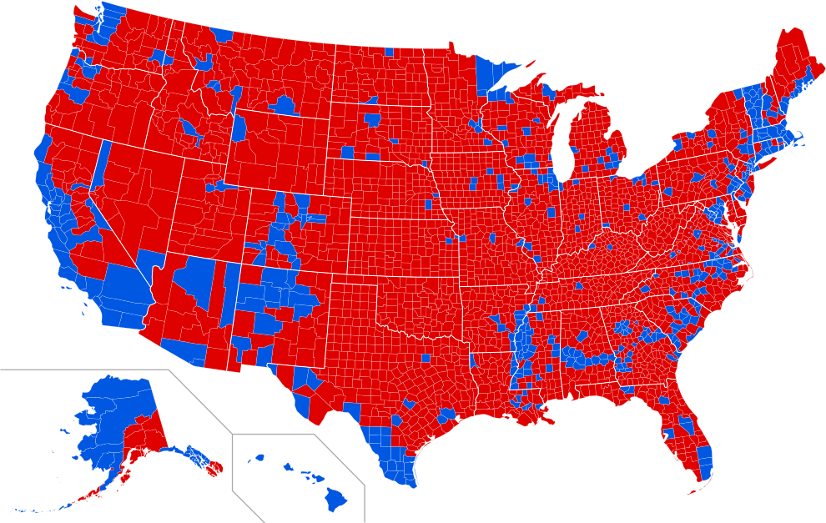

In this context, the Donald's endless outbursts of economic illiteracy match the chart above. At bottom he's all about Trade Wars and Border Wars because he has persuaded the masses in Flyover America that illegal immigrants and ill-paid Chinamen working in the Red Ponzi's teeming export factories have destroyed the American Dream and have stolen their once and former prosperity.
That's not remotely true, of course. Flyover America's prosperity was not destroyed by threats which arose from outside its borders; the whole baleful decline was fostered a few blocks from the very banks of the Potomac - in the Eccles Building.
As we will address in Part 2, the Fed has systematically inflated the wage, cost and price structure of the domestic economy, thereby accounting for the trade collapse and the hollowing out of industrial America---where the Donald's red county voters are the victims.
The chart below shows how and when it all started. Since Nixon's perfidy at Camp David in August 1971, the CPI has exploded upward by 5.18X, and that was virtually the same destruction of the dollar's purchasing power as was reflected in the 5.21X gain in the wages of production and non-supervisory workers in America.
That is, the average wage rate rose from $3.66 per hour in August 1971 to $22.73 per hour in August 2018. But its purchasing power grew not one bit---even as soaring nominal wage costs made American workers sitting ducks for the cheap labor flowing out of China's rice paddies and into its spanking new export factories.
Even when the higher income and stock owning strata of the population---heavily blue county domiciled---is thrown into the mix, the real median family income in America has grown by only 0.66% per annum for the last 47 years.
It was a horrible bargain, but now the final bubble from the age of fiat money and monetary central planning looms over an impaired main street economy and fractured national polity.
When it crashes, the next great financial crisis will begin and in response the desperate powers that still reign in the Imperial City will bring the Donald down with malice aforethought.
But that will only fracture American politics even further as we shall demonstrate in the installments to follow.

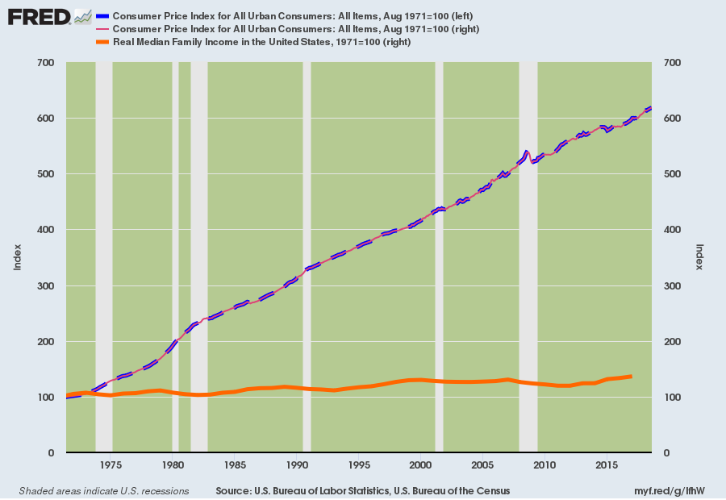

See " 19871019_stock-market-crash-of-1987.htm".
Dollar no longer a commodity-based currency.

